Special Session Chair(s):

- Chair 1 : First & Last Name

- Chair 2: First & Last Name

- Chair 3: First & Last Name

…………………………….







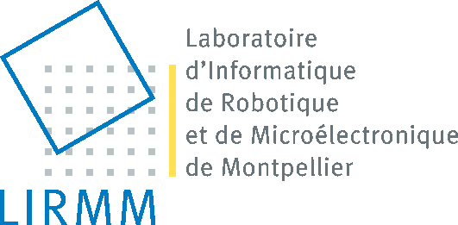


Special Session Title: ……………………………………………

Aims & topics:

……………………………………….
…………………………………
………………………………….
……………………………….

.

Topics of interest:

……………………
……………………….
…………………………
…………………………..

Chair 1,  Affiliation  adress  e-mail adress | Chair 2,  Affiliation  adress  e-mail adress | Chair 3,  Affiliation  adress  e-mail adress

For further information, the contact secretariat is at: iptta@ibisc.univ-evry.fr

2014


International Conference on Image Processing Theory, Tools & Applications

http://ipta14.ibisc.univ-evry.fr

October 14-17, 2014, Paris – France
Call For Special Session

